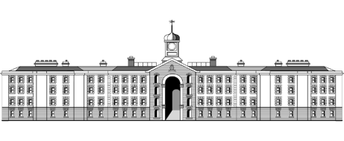

**Griffith College Limerick**

|  |  |  |  |  |  |  |
| --- | --- | --- | --- | --- | --- | --- |
| **Student name:** | **ASSIGNMENT COVER SHEET**  **Sarah Narayamy Tavares Silva & Paula Carine Oehme** | | | | | |
| **Student number:** | **2960992 & 2957903** | | |  | | |
| **Faculty:** | Computing Science | | | | | |
| **Course:** | BSCO in Computing Science | | | Stage/Year: | 1 | |
| **Module:** | **Cient Side Web Development** | | | | | |
| **Study Mode:** | Full time | **🗸** |  | Part-time |  |  |
| **Lecturer Name:** | Tina Lenihan | | | | | |
| **Assignment Title:** | Group Project | | | | | |
| **URL (IF Applicable)** |  | | | | | |
|
|
| **Date due:** 05/05/2018 |  | | | **Date submitted: 05/05/2018** | | |
| **Academic Misconduct:**  *I understand that I will be subject to the penalties imposed for breaches of academic conduct as defined in the College’s Academic Misconduct Procedure (QA J6).*  **Signature: Sarah Narayamy Tavares Silva Date: 05/05/2018**  **Paula Carine Oehme** | | | | | | |

Please note: Students MUST retain a hard / soft copy of all assignments and must SIGN the Assignment Submission Sheet provided by the lecturer / member of Faculty as proof of submission.

**Site Map**

Contact Us

Notable Victories

About Us

Practice Areas

Attorneys

Home

Tax Tributes

Sarah Silva

Civil Rights

Paula Oehme

Criminal Law

**WireFrame Large Screen**

Notable Victories

Practice Areas

Attorneys

About Us

Home

logo

Contact Us

Team Picture

**We fight for you**

**Your business is our business**

Some News:

**TSMP completes Chevron House deal for Oxley Holdings**

**ALB interviews Stefanie Yuen Thio on TSMP's 20th anniversary**

**TSMP acts for SDC to successfully dismiss appelal in dental misconduct case**

Image

Image

Image

Writen by [sarahnarayamy@gmail.com](mailto:sarahnarayamy@gmail.com) and [Paula Carine Oehme](mailto:paula.oehme@gmail.com)

2018

Our Culture

News

Feedback

Contact Us

WireFrame Mobile

Logo

Team Picture

**We fight for you**

**Your business is our business**

Some News:



**TSMP completes Chevron House deal for Oxley Holdings**

Writen by [sarahnarayamy@gmail.com](mailto:sarahnarayamy@gmail.com) and [Paula Carine Oehme](mailto:paula.oehme@gmail.com)

2018

Our Culture

News

Feedback

Contact Us

**Description**

The page was design with the main characteristics found on most of lawyers’ websites. The background picture was chosen due to its compatibility with the area. Thus the background colour also matches the tons of the colour from the background image.

The idea was to make a dropdown menu for the navigation where the sub links would be also horizontal.

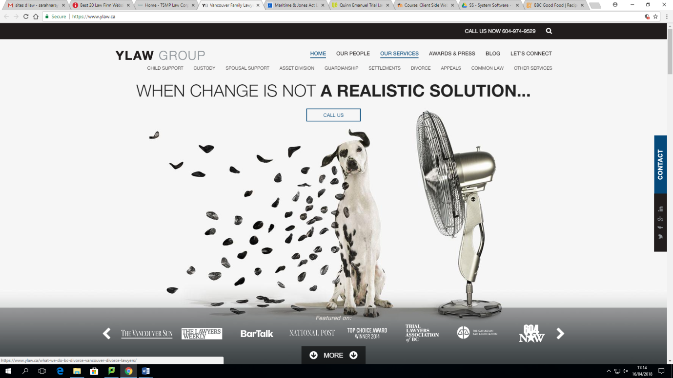

For the mobile version, we decided to do the hamburger option which is the cleanest one.

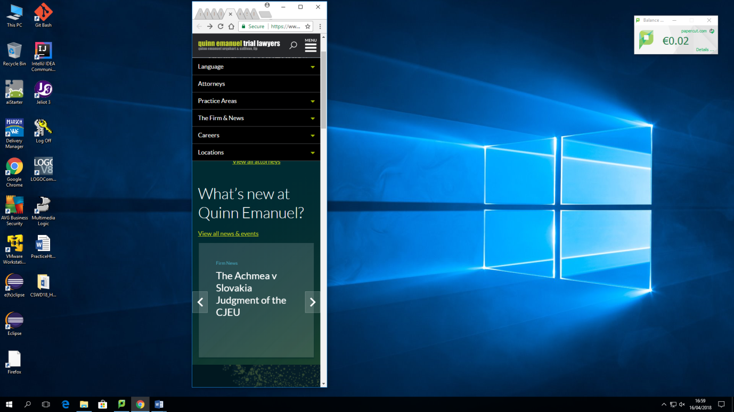

One of the options that we saw on websites related was where each section of the page would be the opposite of the each one. We decided not to follow the idea because it is very easy to get lost, and lose focus.

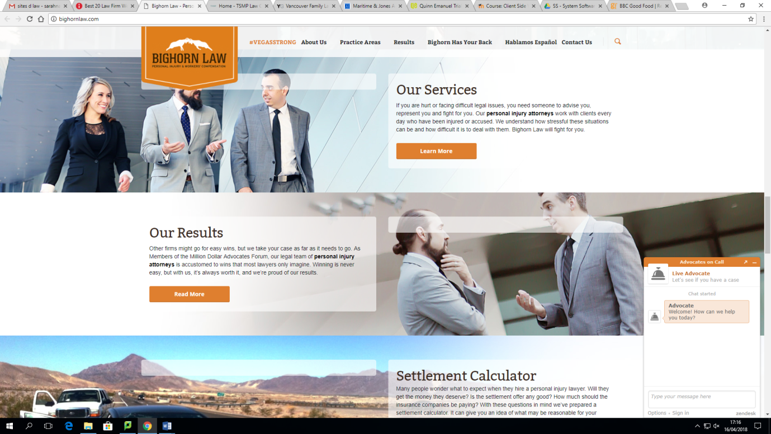

The Paralllax effect was chosen because it gives an idea of movement and interaction with the user.

